D2 DIPOLES FOR LHC-HL UPGRADE v4 draft

**Introduction.** As part of the High Luminosity Upgrade of the LHC (LHC-HL), CERN plans to increase the aperture of the D2 IR dipoles located near ATLAS and CMS. Present CERN plans call for a twin-aperture dipole with an integral field of 40 T·m, an effective length of 9.45 m (the same length as that of the 80 mm-aperture dipoles previously supplied by BNL), a central field of 4.23 T, and an aperture separation of 186 mm. The operating temperature is 1.9 K. The upgrade plan calls for six D2s, four installed with two spare. The RHIC D0 dipole, which has an aperture of 100 mm, has been used as the D2 starting point for optics studies for the HL upgrade. Optics studies reported at LARP-LHC CM18 point to a coil aperture of 105 mm as being optimal. However, there are engineering and cost/schedule issues related to a 5 mm increase in aperture that need careful evaluation.

**Quench performance.** Fig. 1 shows the quench performance of the RHIC D0s (4.5 K). The maximum quench currents ranged from 6.6 kA (4.3 T) to 7.6 kA (4.7 T). Since the maximum quench currents were much higher than the RHIC operating current, the magnets were not trained to a quench plateau. The quench history of the magnets shows that they trained quickly, so reaching the 4.23 T needed for LHC should not be difficult. (The 40 T·m integral field specification includes all margins.)



Fig. 1. Summary quench performance of 24 RHIC D0 dipoles, tested at 4.5 K.

**Field Quality.** The field quality specifications are expected to be close to the usual values, ~ 1 unit at 2/3 of the coil inner radius, 33 mm. Data from a short model will be needed in order to obtain harmonics that meet the specifications for both the geometric and the saturation components. (The thickness of the superconducting cable cannot be specified to the tolerance needed for the coils. Within limits, coil size errors can be compensated by adjustment of pole and/or midplane shims. Calculation of the saturation harmonics is particularly challenging because the apertures are close to one another and because the field in both apertures is in the same direction. Both items point to the need for a model magnet.) Fig. 2 shows the 100 mm RHIC D0 coil with a 20 mm-wide collar in the yoke used for the twin-aperture magnets made for the US-LHC project. The yoke has not been optimized, but the saturation harmonics from this assembly were sufficiently small to permit the conclusion that the harmonics from an optimized coil and yoke would meet specification. Fringe fields will be need to be checked against allowed values.

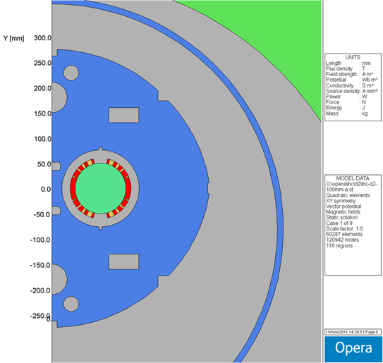

Fig. 2. 100 mm i.d. coil, 20 mm-wide center collars, US-LHC yoke with 192 mm aperture spacing.

**Mechanical Design.** In the straight section of the magnet, the width of the iron between the apertures is 19.75 mm for 105 mm coils and 24.75 mm for 100 mm coils. At the lead end of the magnet, the diameter of the collared coil increases by about two cable widths because of the need to support the leads which exit the single-layer coils at the poles. This can be seen in Fig. 3, which shows the lead end of the US-LHC D2, made using 80 mm coils. For 100 mm or 105 mm coils the aperture separation is too small to use the same approach for support of the pole leads, because the collars would overlap by 7.4 mm or 12.4 mm respectively. The same problem exists at the return end, which uses the larger-diameter collars to reduce the peak field and to have the same saturation at both ends of the magnet. A new method of support is needed. It would be tested in the short model magnet.

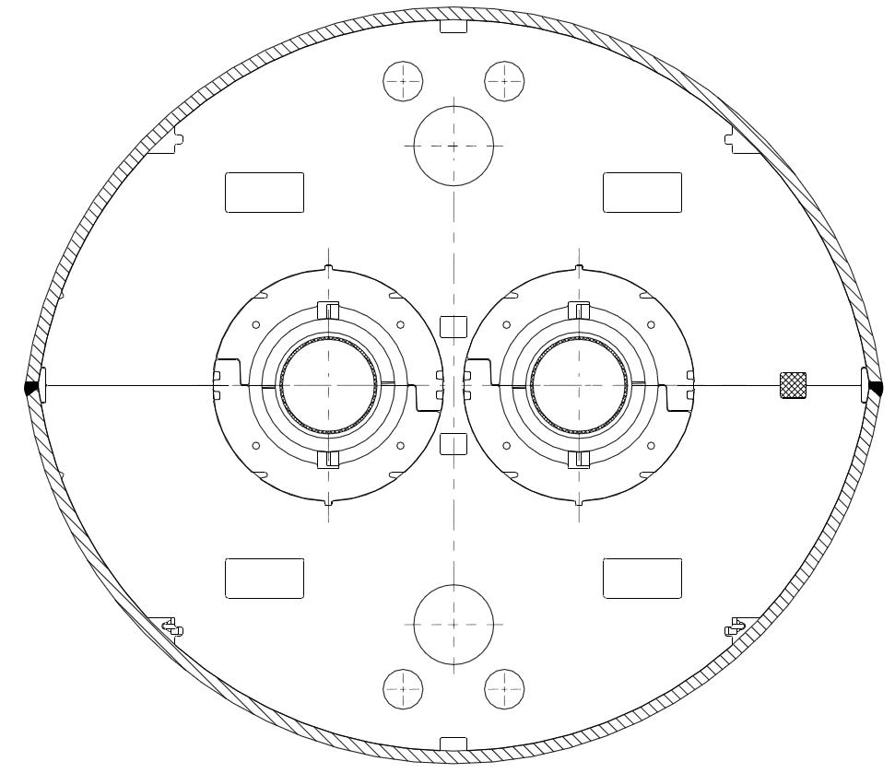

Fig. 3. Lead end of the US-LHC D2 (80 mm coils). The width of iron between the two apertures is 14.6 mm.

**Tooling.** Production at BNL would take advantage of the 10 m coil production tooling (winding machine, cure press, ancillary tooling) that is being restored for use of the APUL project. The 10 m cold mass assembly tooling (collar, yoke, helium vessel, cryostat insertion) has been retained following its use in the US-LHC Project (although collaring tooling would need to be modified for the larger collars). The cryo test facility is also being modified for the APUL project, to accept 10 m magnets. The floor space in the production area now used by the NSLS II light source project will be vacated early in 2013, so there will be sufficient floor space for both D2 dipole and Nb3Sn quadrupole production. The coils for the two types of magnets will most likely be wound and cured on separate fixtures.

The existing RHIC D0 coil tooling is available for use in building a 3.6 m model magnet with 100 mm coils. This tooling would need to be designed and purchased if the coil aperture is 105 mm.

**Magnet components.** If the coil i.d. is 100 mm, no design work for the coil or its components has to be done, except to extend the length from 3.6 m (RHIC D0) to 9.45 m where appropriate. A complete new design would be needed for 105 mm coils. A new collar design is needed for either coil, since the RHIC D0 used the yoke as collar. If the yoke perimeter does not change from that used for the US-LHC twin-aperture magnets, no design work will be needed for the heat shield, cryostat, etc (Fig. 4).

The wall thickness of the coil’s cold bore tube needs study. An initial check of vendors found none who would make 10 m lengths of seamless tube in non-standard sizes.

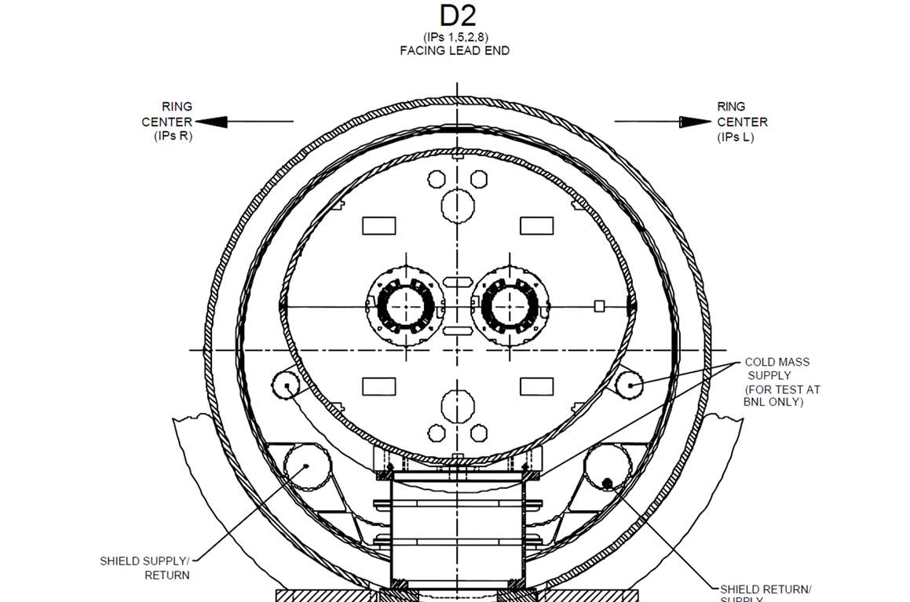

Fig. 4. Cross section of D2 US-LHC (US-LHC, 80 mm coil aperture)

**Long Lead Procurements.** Magnet components that require Long Lead Procurement include NbTi cable, yoke, shell, cold bore tube, collars, and cryostat. (Yoke material should probably be purchased at the same time as the yoke material for the quads.) LLP tooling includes the mandrel and coil form block.